DESIGN SPECIFICATIONS

OVER VIEW OF LEVEL DESIGN:

Keeping the same basic level design as original game but the level is looked at, analysed and justified as if the game was ours and we were designing it from scratch.

CHANGES MADE FROM ORIGINAL GAME:

-only 1 ball not 3: takes away allowance of mistakes made by new players but throws them in the deep end challenging them to try again and build their skill. Baptism by fire lol. One ball emphasises it’s a skill based game. It also pushes the challenge on the player – how far can you go with one ball, how well can you predict and manipulate the system.

-object in the middle (heart) that gives bonus points when hit by ball (eye). Adds juice.

BASIC LAYOUT STRUCTURE

* 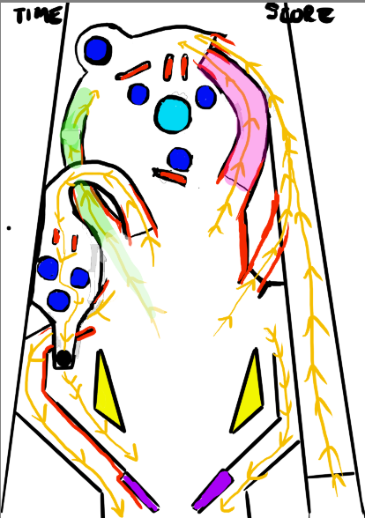score and time on top corners
* Black outlines: solid areas ball does not pass
* Orange arrows shows passages ball can pass
* Red: barriers
* Purple: two paddles
* Yellow: barriers that bounce the ball in an erratic manner.
* Dark blue: gives player score and bounces them off lightly.
* Light blue: bigger score giver and bounces ball off a little harder.
* Green: slows down ball slightly
* pink: speeds up ball

PROGRAMMER:  
- The distance between each paddle when held horizontal should have a space just a little bigger than the size of the ball so the ball can potentially fall through.

-Speed of ball increases over time. Ball should not go so fast it goes through walls.

-the angle of the paddle. Paddle physics. Paddle shouldn’t move too slow or too fast. Move in a manner comfortable for the player.

BASIC ART LAYOUT

* 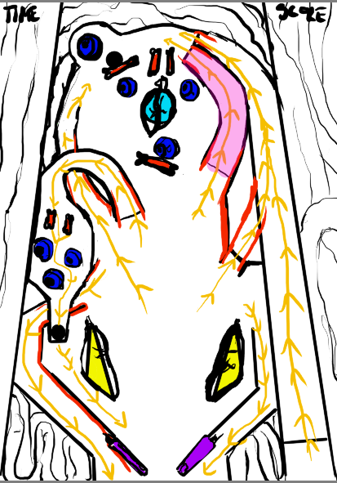dark blue: eye ball
* Red: small finger bones
* Light blue: heart
* Yellow: kidney/lung
* Purple: severed finger
* Textured background in colour pallet. 4 shades for depth.
* Trails of guts for background of outside the game.
* Font for time and score that sticks out from the background.
* Ball: metal pinball.
* Subtle arrows

ANIMATIONS:

-Rolling ball animation.

-Heart beating. Small pulse due to size it takes up in game

-eyes looking around.

-some eyes following ball(code animation- duncan)

-lungs/kidneys pulsing a little.

COLOUR PALLET FOR BACKGROUND:

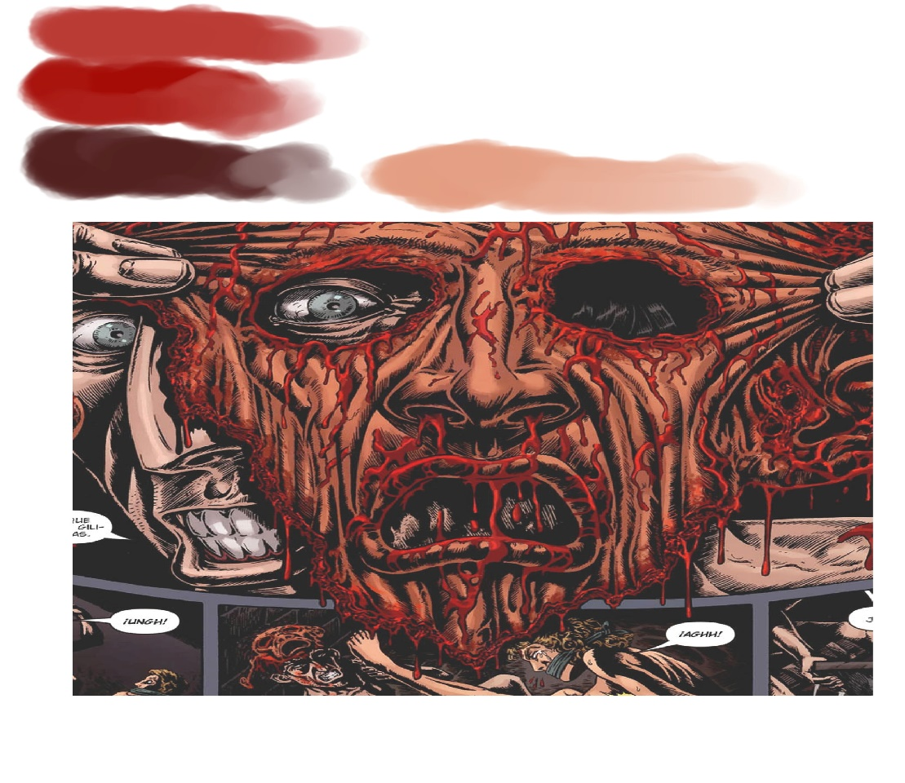

ARTISTS KEEP IN MIND:

-keep background less saturated so the colours don’t conflict with actual game

-keep paddle as the paddle shape just try and draw a finger with its shape

-don’t make assets too big or too small.

LEVEL DESIGN CHOICES:

-only 1 ball not 3: takes away allowance of mistakes made by new players but throws them in the deep end challenging them to try again and build their skill. Baptism by fire lol. One ball emphasises it’s a skill based game. It also pushes the challenge on the player – how far can you go with one ball, how well can you predict and manipulate the system.

-when the game starts the ball shoots from the bottom right and out the top right of the game. The ball has to fall down right to the bottom of the paddles before the player has to interact with it. This allows the player time to anticipate the ball before it reaches them.

- the level is set up so the ball will interact with at least two different environmental aspects before the player has to interact with the ball. The player also gets to see how the ball interacts with the environment as it falls down to the paddles to understand how they accumulate score and what causes the ball to move certain ways.

-The two environmental elements close to the paddles that causes them to bounce erratically creates suspense when the ball is falling towards the paddles because of the unpredictable manner the ball might be bounced. The two elements are also positioned where they can play off each other bouncing from one side to the next, testing the players ability to keep track of the ball and their reaction. This increases the players immersion and concentration in the game.

-the player has 5 possible paths to shoot the ball in.

-the angle of two paths in the game are placed at almost perfect angles that the player is able to aim and strategize for. Players successfully hitting the ball into these paths gives the player the feeling of control and direction.

-there are two other paths the player can hit the ball in that are more difficult to aim for. This gives the player a challenge to manipulate both the ball and paddle and aim for. Successfully doing this is a potential set up for an epic moment.

- the arrows gives new players an idea as to where the ball can go and the direction it is going to go in when it enters certain paths.

-The distance between each paddle when held horizontal should have a space just a little bigger than the size of the ball so the ball can potentially fall through but the player has a chance to save the ball if quick enough.

-the game is designed to focus on the skill of the player and therefore the environmental objects that the ball can bounce off of are limited and strategically chosen so the predictability of the game is not lowered. With too many environmental factors on the ball it would bounce around a lot more, requiring less input from the player, either making the game too difficult or breaking the immersion of the player. There needs to be a balance between predictability for the player and unpredictability due to the environment.

-the physics of the game is designed not to feel random. The game is about predicting the ball, with some unpredictability from environmental objects. Most of the challenge should come from the speed of the ball and the players reaction which builds up over time.

-the art and particle effects were designed to add juice to the game and align with the theme, but not distract from the game and over power the ball. That is why the ball is silver as opposed to the rest of the game that is in shades of red. The sound of the game is also to communicate to the player the impact they are making on the game and that the game is alive.